Evidence for Analysis and Design Unit.

Kynan Song

Cohort 16

Date:

AD1 – Use Case Diagram

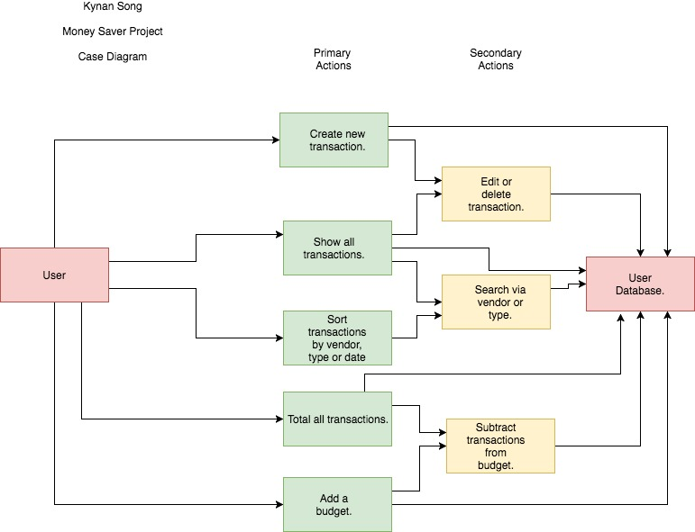

AD2 – Class Diagram

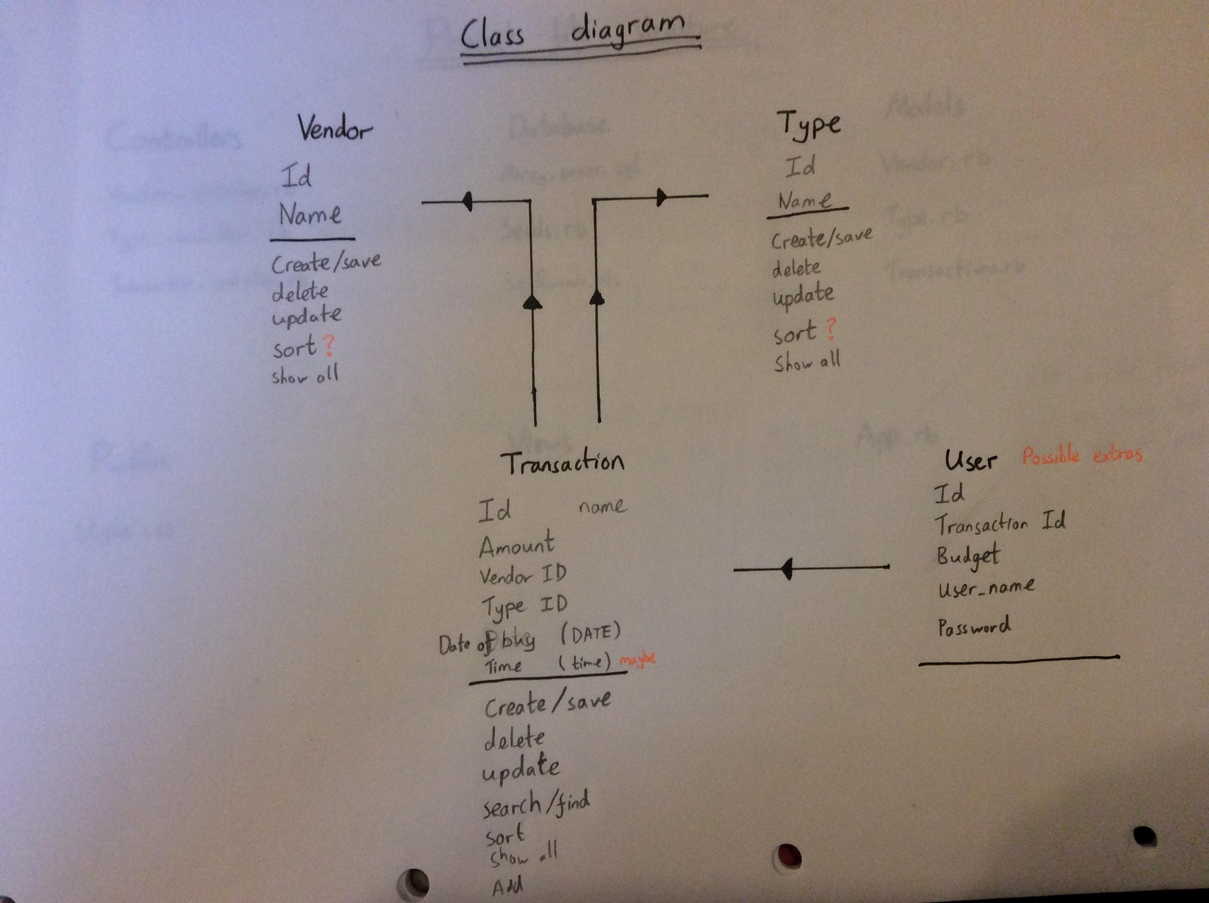

AD3 – Object Diagram

AD4 – Activity Diagram

AD5 – Inheritance Diagram

AD6 – Implementations Contraints